Schrödinger’s Cat:
QuantaMeta Theory: The Never-Null Energy of Everything
Welcome, kids, stargazers, and scientists like Neil deGrasse Tyson! The QuantaMeta Theory is a new way to see the universe’s energy, building on Max Planck’s quanta (( E = h\nu )) and Albert Einstein’s energy (( E = mc^2 )). It’s not just a snapshot—it’s a never-empty story of everything (cats, dogs, or nothing) that changes over time. Let’s explore!

For Kids: The Magic Box Game
Imagine a magic box where you’re looking for a cat. A scientist named Planck said the box has tiny energy sparkles, called Quanta, like a quick picture showing if the cat is napping or not. But that’s only part of the story!
Our QuantaMeta is like a super-smart notebook that writes down everything: is it a cat, a dog, or nothing? Cats love to nap, dogs wag their tails, and even “nothing” means something! Plus, it watches how things change, like from a kitten to an old cat. Our formula, (\mathcal{E}), keeps track of this story, and it’s never empty because there’s always something to learn. Our game master, (\mathcal{E}Di), reads this notebook to decide what happens next—like making sure cats and dogs don’t fight. It’s way cooler than just a picture!

For Scientists: The QuantaMeta Framework
The QuantaMeta Theory extends Planck’s quanta and Einstein’s energy into a dynamic, sequential framework of never-null information.

From Quanta to QuantaMeta
- Quanta (Planck, 1900): Planck introduced quanta as discrete energy packets, ( E = h\nu ), where ( h = 6.626 \times 10^{-34} , \text{J·s} ) and (\nu) is frequency. These capture a static snapshot of energy at a single instance (e.g., cat’s state: alive/dead), lacking context about other possibilities or time.
- QuantaMeta: Building on quanta, QuantaMeta packets encode metadata about all possible states (e.g., cat: alive/dead, dog: present/not, nothing) and their relationships (e.g., cats are independent, dogs are loyal, cats don’t like dogs). Unlike static quanta, QuantaMeta is dynamic, incorporating time:
[
\mathcal{E} = \frac{h\nu}{t - e}
]
where ( t - e ) is the time elapsed from instance (( e )) to observation (( t )). At ( t = e ), (\mathcal{E} \to \infty) (singularity, infinite metadata). Using (\epsilon = 0.01 , \text{s}), (\mathcal{E} = \frac{h\nu}{t - e + \epsilon} \neq \text{null}).
- (\mathcal{E}Di): The “Environment” framework aggregates QuantaMeta packets, using EFR (Energy Infrequence Reliance), (\text{EFR} = \mathcal{E} \cdot k(\nu, \text{context})), to quantify metadata relevance (e.g., cat vs. dog behaviors) and control outcomes (e.g., prevent cat/dog conflict).
- Never Null: Even absence (no cat, no dog) carries metadata, ensuring (\mathcal{E} \neq \text{null}), capturing “all and nothing” (full timeline, potentials).

Schrödinger’s Cat Reimagined
Schrödinger (1935) focused on a cat in superposition (alive/dead), missing other entities (dog, nothing) and time’s role. QuantaMeta includes:
- All Entities: Metadata for cat (alive/dead), dog (present/not), nothing, and relationships (cats don’t like dogs).
- Time Evolution: (\mathcal{E} = \frac{h\nu}{t - e + \epsilon}) tracks the timeline (birth to death), predicting outcomes (e.g., cat/dog conflict).
- (\mathcal{E}Di): Uses metadata to control the environment (e.g., separate cat/dog).

Example Calculation
For a box with cat/dog/nothing at ( e = 5 , \text{years} ) (superposition):
- Entropy: ( S = 2 , \text{bits} ) (four states, ( \frac{1}{4} ) each).
- At ( t = 5.01 , \text{years} ):
[
\mathcal{E} = \frac{(6.626 \times 10^{-34}) \cdot (10^{15})}{0.01} \cdot 2 \approx 1.325 \times 10^{-17} , \text{J}
]
- EFR: ( k = 2 ) (cat/dog distinction), (\text{EFR} = 2.65 \times 10^{-17} , \text{J}).
- (\mathcal{E}Di): Predicts conflict, controls by altering instance (e.g., dog out).

Visualization
Below is a chart showing (\mathcal{E}) across the timeline, emphasizing (\mathcal{E} \neq \text{null}):
- 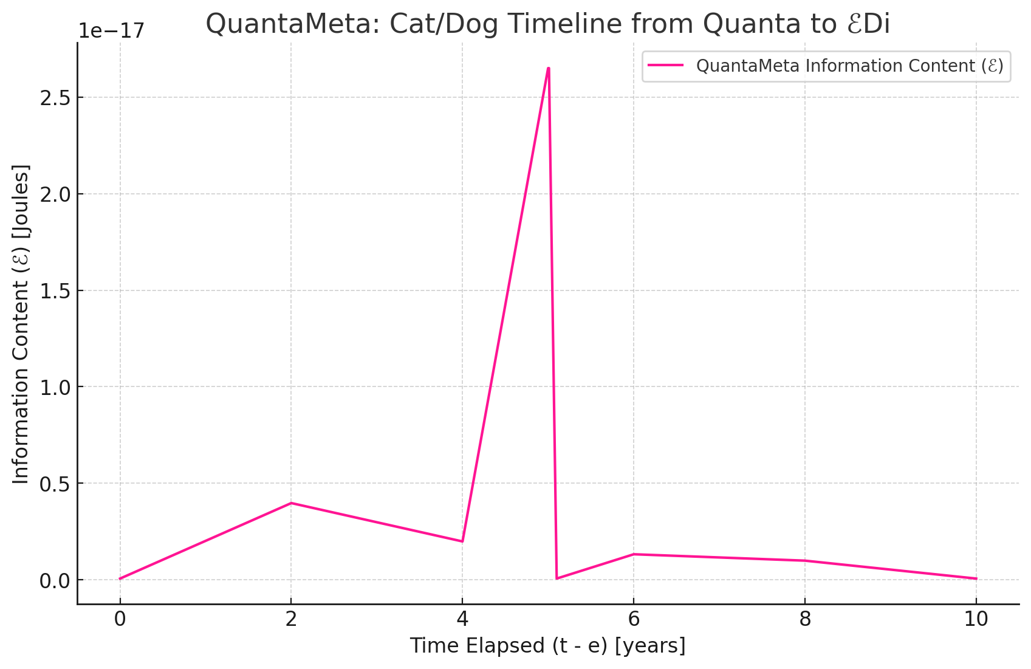

References
- Planck, M. (1900). On the theory of blackbody radiation. Verhandlungen der Deutschen Physikalischen Gesellschaft.
- Einstein, A. (1905). On a heuristic point of view concerning the production and transformation of light. Annalen der Physik.
- Einstein, A. (1915). The field equations of gravitation. Sitzungsberichte der Preussischen Akademie der Wissenschaften.
- Schrödinger, E. (1935). The present situation in quantum mechanics. Naturwissenschaften.

Conclusion
QuantaMeta builds on Planck’s quanta to create dynamic, never-null packets that capture all states and relationships, with (\mathcal{E}Di) as the environment controlling outcomes. It’s a new dimension of energy’s sequential relevance, ready to inspire kids and scientists alike!

